Report by:
Deston Guay (Team Leader)
Randy Tung
Eugene Lee
Benedict Say
Darwin Tan
Joshua Tan

CSCI212 – Team C1 Assignment 2 Report

CSCI222 Assignment 2 Report

Team Number : <C1 >

 | Student Number | Name | Email Address
1 | 6096761 | Deston Guay Jie Khai | Tel: 98376600 Email: djkg997@uowmail.edu.au
2 | 6097558 | Darwin Tan | Darwin_tan88@hotmail.com
3 | 6097364 | Benedict Say | Bensay22@gmail.com
4 | 6096888 | Eugene Lee | Eugene_2394@hotmail.com
5 | 6096839 | Joshua Tan | 1.2silverfish@gmail.com
6 | 6097340 | Randy Tung | 123613p@gmail.com

Table of Contents
Contents
Project Overview 3
Roles and Responsibility 5
Risk Analysis and Counter Measures 6
Design Artefacts - Use Cases (Iteration 1) 7
Design Artefacts - Use Cases (Iteration 2) 8
Design Artefacts - Activity Workflow (Iteration 1) 9
Design Artefacts - Activity Workflow (Iteration 2) 10
Design Artefacts - Component Diagram (Iteration 1) 11
Design Artefacts - Component Diagram (Iteration 2) 15
Design Artefacts - Class Diagram (Iteration 1) 21
Design Artefacts - Class Diagram (Iteration 2) 22
Design Artefacts - Sequence Diagram (Iteration 1) 22
Design Artefacts - Sequence Diagram (Iteration 2) 22
Design Artefacts - Deployment Diagram (Iteration 1) 22
Design Artefacts - Deployment Diagram (Iteration 2) 22
Appendix A - Formal Meeting Records 23
Appendix B - Individual Work Diaries 24
Appendix C - Evidence of using VCS (Version Control Software) 30

Project Overview

In this assignment, the primary focus is targeted at the ability to provide a warehouse inventory management system for the user. This system is crucial as it will strive to streamline processes and optimise productivity and day-to-day operations. Staff members are able to make use of the provided summary data to conduct critical decision-making operations that will directly impact the organization.

It is therefore paramount for the organization to have an effective system in place with an effective security coverage, pinpoint accuracy for data summary and a robust system to maintain the highest uptime.

- "Vision"

We strive to create a program which is closely suited to user requirement and have as little constraints as possible that will impede the user’s experience.

- Initial Use-Case Model

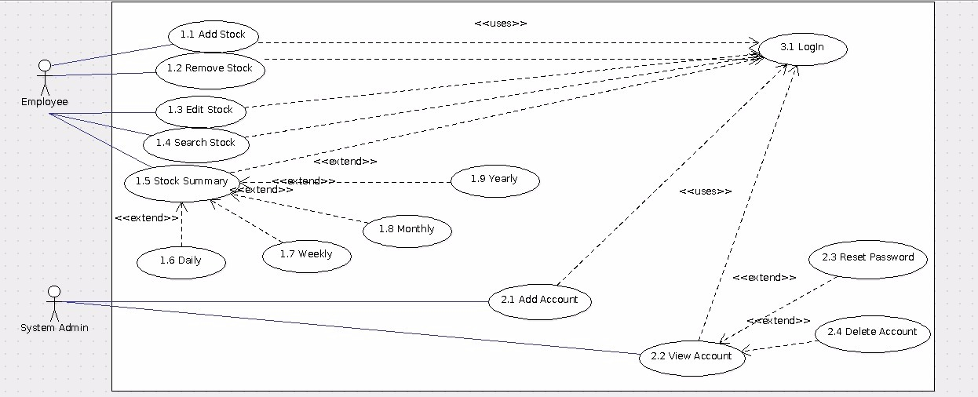

In our warehouse management tool, we would have 2 actors, the employee and system admin, both of which would be required to login before they are able to further access the system.

The employees would be able to perform basic stock management duties such as the adding of stocks, removal of stocks, searching of stocks and a summary of all stock in the current inventory.
The employee would be able to further narrow down his/her requirements for the summary report. The available options are: Daily, Weekly, Monthly and Yearly.

The system admins would only be able to manage the employee accounts. They are able to reset the passwords and unlock the employee’s account if they have failed to login 3 times. The system admin is also responsible for the creation of new accounts for new employees and the removal of old and redundant accounts when employees have left the company.

- Project Plan

- Please refer to "Stud_GanttChart_Sample.xls" for planning your system development activities

- Overlay your RUP iterations to Gantt charts timeline (e.g. which phase-iteration relates to which week?

- Also, within each week, what are the development activities, start-end date, duration (no. of man-days), and who is in charge of each activity?)

- If you are pasting screen-shots of your project planning into this sub-section, please ensure all the wordings / text are clearly visible

(i.e. assume anything < Arial Font_Size_10 is NOT easily visible to your company's senior management!)

Roles and Responsibility

Team Number: <C1>

 | Student Name | Role | Artefacts
1 | Deston Guay | Manager, Lead Designer | Add2.CPP, sha256.CPP, sha256.H, user.txt
2 | Randy Tung | Lead Documenter, Designer | Report, Presentation Slides, SRS
3 | Eugene Lee | Lead Tester, Documenter, Designer | Report, Presentation Slides, SRS
4 | Benedict Say | Documenter, Tester | Report, Presentation Slides, SRS
5 | Darwin Tan | Designer, Tester | Report, Presentation Slides, SRS
6 | Joshua Tan | Designer, Systems Integration | Stock.CPP, Stock.H, DAWAE.exe

Risk Analysis and Counter Measures

 | Impact Type | Risk Seriousness (%) | Likelihood of Occurrence (%) | WBS  (affected work / task) | Risk Description
1 | Budget | 30% | 5% | All | All employees demand an increment of salary.
2 | Competitive | 50% | 30% | Stock | Potential competitors to institute a price war to cause a drop in revenue.
3 | Compliance | 10% | 5% | All | A risk level that the company will be deemed to have violated a law or regulation.
4 | Operations | 50% | 10% | All | The potential risk for failures of the company’s core business processes.
5 | Security | 20% | 20% | All | Risks related to physical and information security.

 | Risk Description | Proposed Mgmt Plan | (Possible) Reduction in Risk Seriousness (%)
1 | All employees demand an increment of salary. | Plan 1: Propose appropriate increment of salary | -20%
1 | All employees demand an increment of salary. | Plan 2: Replace disgruntled workers | -20%
2 | Potential competitors to institute a price war to cause a drop in revenue. | Plan 1: Offer discounts and benefits for customers | -50%
3 | A risk level that the company will be deemed to have violated a law or regulation. | Plan 1: Ensure that the country’s laws and legislature are adhered to at all times. | -10%
4 | The potential risk for failures of the company’s core business processes. | Plan 1: Ensure business continuity plan is in place and rehearsed with employees. | -50%
5 | Risks related to physical and information security. | Plan 1: Review security processes frequently | -10%
5 | Risks related to physical and information security. | Plan 2: Review inactive accounts and implement a password change policy | -10%

Design Artefacts - Use Cases (Iteration 1)

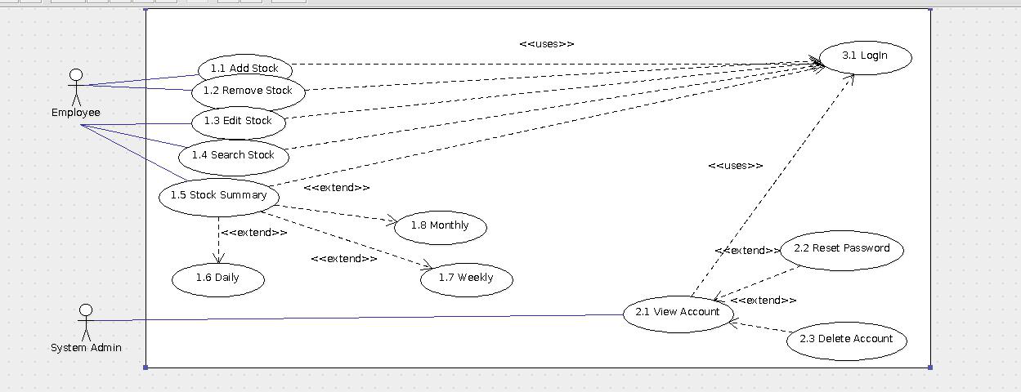

Design Artefacts - Use Cases (Iteration 2)

Design Artefacts - Activity Workflows (Iteration 1)

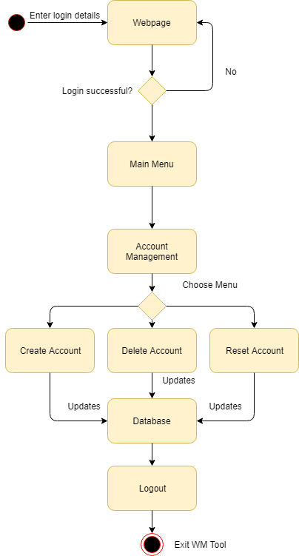

Design Artefacts - Activity Workflows (Iteration 2)

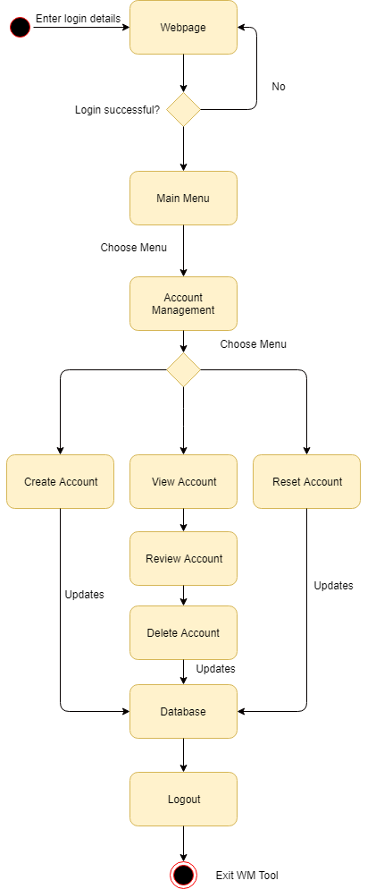

Design Artefacts - Component Diagrams (Iteration 1)

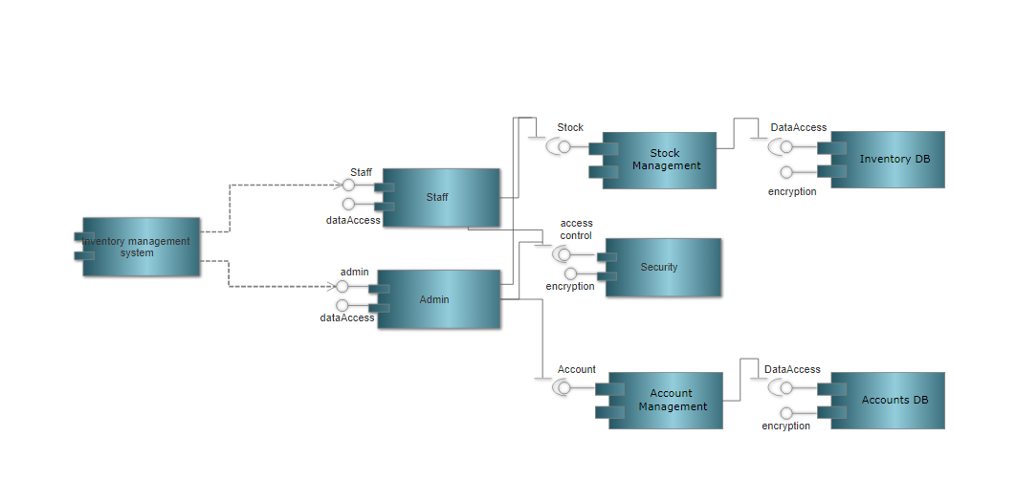

Design Artefacts - Component Diagrams (Iteration 2)

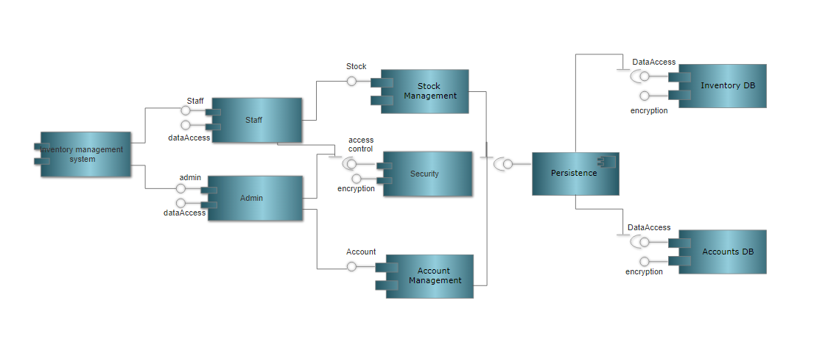

Design Artefacts - Class Diagrams (Iteration 1)

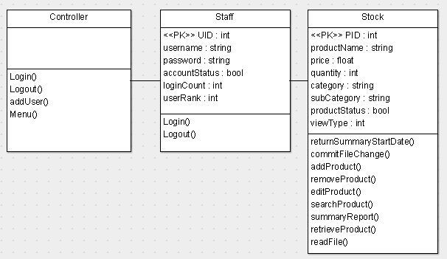

Design Artefacts - Class Diagrams (Iteration 2)

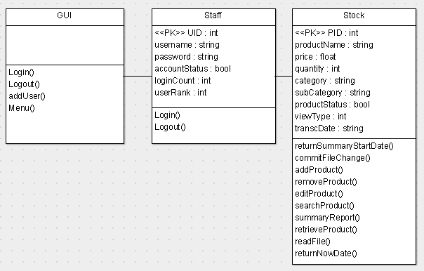

Design Artefacts - Sequence Diagrams (Iteration 1)

Add Stock

Login

Remove Stock

Reset Password

Design Artefacts - Sequence Diagrams (Iteration 2)

Design Artefacts - Deployment Diagrams (Iteration 1)

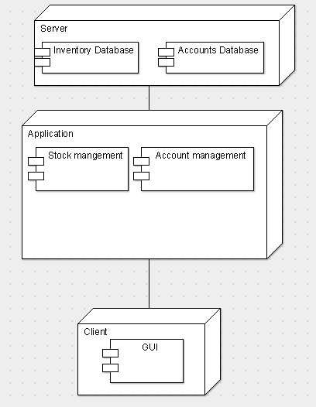

Design Artefacts - Deployment Diagrams (Iteration 2)

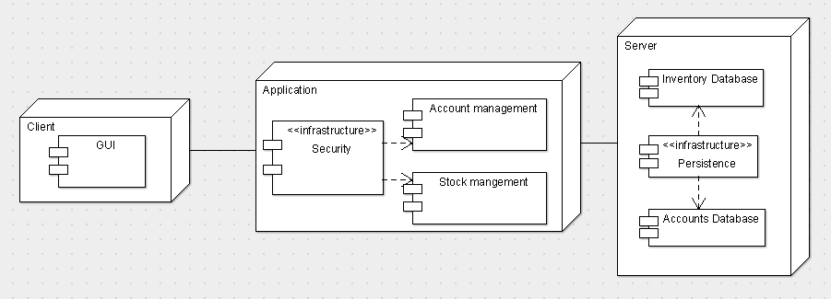

Design Artefacts - <Any other diagrams> (Iteration 1)

Depending on your system's software architecture, there may be many other diagrams (e.g. ER-Model, State / Interaction / Activity Diagrams, etc) which are applicable and should be reflected in your Design Artefacts section of your report.

Please "reuse the same structure" you see for the earlier sections on Use Case / Class / Component diagrams, together with 2 iterations version, for your diagrams in this section.

You may use any diagramming tool to develop your diagrams.

Iteration 1 is based on your team's "INITIAL" understanding of the system.

Note 1 : Your diagram should be developed using standard UML symbols and notations that is relevant for that particular type of diagram!

Note 2 : this section can span as many pages as necessary

Note 3 : If you are pasting screen-shots (from your adopted diagramming tool) into this sub- section, please ensure all the wordings / text are clearly visible

Design Artefacts - <Any other diagrams> (Iteration 2)

Depending on your system's software architecture, there may be many other diagrams (e.g. ER-Model, State / Interaction / Activity Diagrams, etc) which are applicable and should be reflected in your Design Artefacts section of your report.

Please "reuse the same structure" you see for the earlier sections on Use Case / Class / Component diagrams, together with 2 iterations version, for your diagrams in this section.

You may use any diagramming tool to develop your diagrams.

Iteration 2 is based on your team's "LATEST" understanding of the system.

In general, the diagrams in later iterations should be more refined, more evolved, capture more details than diagrams developed in earlier iterations

Note 1 : Your diagram should be developed using standard UML symbols and notations that is relevant for that particular type of diagram!

Note 2 : this section can span as many pages as necessary

Note 3 : If you are pasting screen-shots (from your adopted diagramming tool) into this sub- section, please ensure all the wordings / text are clearly visible

Test Plan Design

Depending on your system's software architecture, there may be many different classes, with many different implemented methods(), whose functionalities need to be tested.

Your team should describe how they intend to test their functionalities to ensure the methods() work as designed.

Below table provides a sample structure, to organize your content. You can reuse this structure to cover as many other important methods() as necessary.

Test Plan for :

<Relate to fuctional requirement>

Club Membership Management - The system should allow the administrator to add new members

Test Case ID: | Description | Expected Outcome | Participating Program's Class & Method to be tested | Participating CPPUnit Test Program's Class & Method doing the testing
E.g.  CM-1 | E.g.  To test for adding a new member's name "John Anderson" | E.g.  System should output a message like "Member : John Anderson created successfully".  The last array slot in the member array should contain the string " John Anderson " | E.g.  Class Name : ManageMember  Method Name :  bool createNewMember (string name) | E.g.  CPPUnit Class Name : TestManageMember  Method Name :  void testCreateNewMember (string name)
E.g.  CM-2 | E.g.  To test for adding an EXISTING DUPLICATE member's name "John Anderson" | E.g.  System should output a message like "Error, member : John Anderson already exists".  The total no. of elements in the member array should remain the same | E.g.  Class Name : ManageMember  Method Name :  bool createNewMember (string name) | E.g.  CPPUnit Class Name : TestManageMember  Method Name :  void testAddingExistingMember (string name)

Appendix A - Formal Meeting Records

Construction Phase - Iteration 1

Date: | 12/02/18
Start Time: | 1247 Hrs
End Time: | 1340 Hrs
Minutes: | Joshua Tan
Present: | Deston Guay (Team Leader), Joshua Tan, Darwin Tan, Eugene Lee, Randy Tung, Benedict Say
Absent: | N/A

1 | Item Actions | Remarks
1.1 | Change of class diagram.
1.2 | Change of data dictionary.
1.3 | Minor changes to sequence diagram.
1.4 | Change activity diagram.
1.5 | Component diagram 1st iteration
1.6 | Deployment diagram 1st iteration
1.7 | Identifying new risk analysis and counter measures
1.8 | Start the coding for the program.
2 | Review of Assignment Document
2.1 | The team reviews the document for assignment 2.
3 | Assignment of Work
3.1 | Class diagram will be changed by Randy and Benedict. | Randy and Benedict
3.2 | Sequence diagram will be changed by Eugene. | Eugene
3.3 | Data dictionary will be changed by Joshua and Darwin. | Joshua and Darwin
3.4 | Coding will be started by Joshua and Deston. | Joshua and Deston
3.5 | Component & deployment diagram will be done by Eugene | Eugene
4 | Follow up Action Items | To be present by
4.1 | Members will present their respective diagrams and to edit the diagram based on member comments | All
4.2 | Joshua and Deston will present their codes and members will give their feedbacks
5 | Conclusion
5.1 | Team Leader concluded the meeting after there are no further inputs from team members.
5.2 | Meeting is adjourned.

Actions to be taken | Affected Party(s)
Coding | Deston Guay
Data Table, Minutes & Coding | Joshua Tan
Component & Deployment  Diagram | Eugene Lee
Class Diagram | Benedict Say
Activity Diagram | Randy Tung
PowerPoint Slides, Document  & Data Table | Darwin Tan

Construction Phase - Iteration 2

Date: | 15/02/18
Start Time: | 1130 Hrs
End Time: | 1224 Hrs
Minutes: | Joshua Tan
Present: | Deston Guay (Team Leader), Joshua Tan, Darwin Tan, Eugene Lee, Randy Tung, Benedict Say
Absent: | N/A

 | Item Actions | Remarks
 | Confirmation of action items from previous meeting.
Progress from previous iteration.
Follow-up Action Items
1 | Action Items from Previous Meeting
1.1 | Eugene presented his 1st iteration of component and deployment diagram.
1.2 | Benedict and Randy presented their class diagram.
1.3 | Joshua and Darwin stated that they have to change their data dictionary to suit the changes in Class Diagram.
1.4 | Randy stated that everyone to upload their diagram in the repository.
1.5 | Deston and Joshua presented the codes that they have done.
2 | Progress of final iteration
2.1 | Randy and Benedict acknowledge the feedback from the other group members and will work on minor changes to the final class diagram | To Team
2.2 | Everyone cross-checks the diagram and comes to a mutual understanding
3 | Follow-up Action Items
 | 1. Team Members will present their final respective diagrams by the next minutes | To Team
 | 2. Team Members are to integrate their diagrams into a combined PowerPoint slide and report. Randy has volunteered to compile the team’s work into a single slide and report. | To Team
 | 3. Members helped out with the coding and troubleshooting. | To Team
4 | Conclusion
4.1 | Team Leader concluded the meeting after there are no further inputs from team members.
4.2 | Meeting is adjourned.

Transition Phase - Iteration 1

Date: | 17/02/18
Start Time: | 1700 Hrs
End Time: | 1803 Hrs
Minutes: | Joshua Tan
Present: | Deston Guay (Team Leader), Joshua Tan, Darwin Tan, Eugene Lee, Randy Tung, Benedict Say
Absent: | N/A

1 | Item Actions | Remarks
1.1 | Confirmation of action items from previous meeting.
1.2 | Code testing for bugs and errors.
1.3 | Testings to meet the user end requirements.
1.4 | Compiling and checking of documentations.
2 | Confirmation of action items from previous meeting
2.1 | Team made changes to the documentations.
2.2 | Making sure the program is running consistently.
3 | Follow up action
3.1 | Compiling of all the reports.
3.2 | Fine-tuning and checking of codes.
4 | Meeting adjourned
4.1 | Meeting is adjourned.

Transition Phase - Iteration 2

Date: | 19/02/18
Start Time: | 1600 Hrs
End Time: | 1642 Hrs
Minutes: | Joshua Tan
Present: | Deston Guay (Team Leader), Joshua Tan, Darwin Tan, Eugene Lee, Randy Tung, Benedict Say
Absent: | N/A

1 | Item Actions | Remarks
1.1 | Confirmation of action items from previous meeting.
1.2 | Testing’s to meet the user end requirements.
1.3 | Finalizing documentations.
2 | Confirmation of action items from previous meeting.
2.1 | Team made final amendments to the documentations.
2.2 | Running the finished program to ensure that it’s presented in a uniformed manner.
3 | Meeting adjourned
3.1 | Meeting is adjourned.

Appendix B - Individual Work Diaries

Team Member 1 : John Anderson

Construction Phase - Iteration 1

- Copy and Paste your formal meeting minutes for Construction Phase, iteration 1 here.
- You can refer to Assn 1 Qn Paper, Appendix B, bullet point 5 for a summary of contents to be included.
- Note: this section can span as many pages as necessary

Construction Phase - Iteration 2

- Copy and Paste your formal meeting minutes for Construction Phase, iteration 2 here.
- You can refer to Assn 1 Qn Paper, Appendix B, bullet point 5 for a summary of contents to be included.
- Note: this section can span as many pages as necessary

Construction Phase - Iteration 3 (Optional)

- Copy and Paste your formal meeting minutes for Construction Phase, iteration 3 here.
- You can refer to Assn 1 Qn Paper, Appendix B, bullet point 5 for a summary of contents to be included.
- Note: this section can span as many pages as necessary

Transition Phase - Iteration 1

- Copy and Paste your formal meeting minutes for Transition Phase, iteration 1 here.
- You can refer to Assn 1 Qn Paper, Appendix B, bullet point 5 for a summary of contents to be included.
- Note: this section can span as many pages as necessary

Transition Phase - Iteration 2 (Optional)

- Copy and Paste your formal meeting minutes for Transition Phase, iteration 2 here.
- You can refer to Assn 1 Qn Paper, Appendix B, bullet point 5 for a summary of contents to be included.
- Note: this section can span as many pages as necessary

Team Member 'N' : Xxxx Xxxx

Construction Phase - Iteration 1

- Copy and Paste your formal meeting minutes for Construction Phase, iteration 1 here.
- You can refer to Assn 1 Qn Paper, Appendix B, bullet point 5 for a summary of contents to be included.
- Note: this section can span as many pages as necessary

Construction Phase - Iteration 2

- Copy and Paste your formal meeting minutes for Construction Phase, iteration 2 here.
- You can refer to Assn 1 Qn Paper, Appendix B, bullet point 5 for a summary of contents to be included.
- Note: this section can span as many pages as necessary

Construction Phase - Iteration 3 (Optional)

- Copy and Paste your formal meeting minutes for Construction Phase, iteration 3 here.
- You can refer to Assn 1 Qn Paper, Appendix B, bullet point 5 for a summary of contents to be included.
- Note: this section can span as many pages as necessary

Transition Phase - Iteration 1

- Copy and Paste your formal meeting minutes for Transition Phase, iteration 1 here.
- You can refer to Assn 1 Qn Paper, Appendix B, bullet point 5 for a summary of contents to be included.
- Note: this section can span as many pages as necessary

Transition Phase - Iteration 2 (Optional)

- Copy and Paste your formal meeting minutes for Transition Phase, iteration 2 here.
- You can refer to Assn 1 Qn Paper, Appendix B, bullet point 5 for a summary of contents to be included.
- Note: this section can span as many pages as necessary

Appendix C - Evidence of using VCS (Version Control Software)

Version Control Software used: Github & Github Desktop

Screenshot #1 - Contents in the VCS's Root Folder containing all Repository Project Files

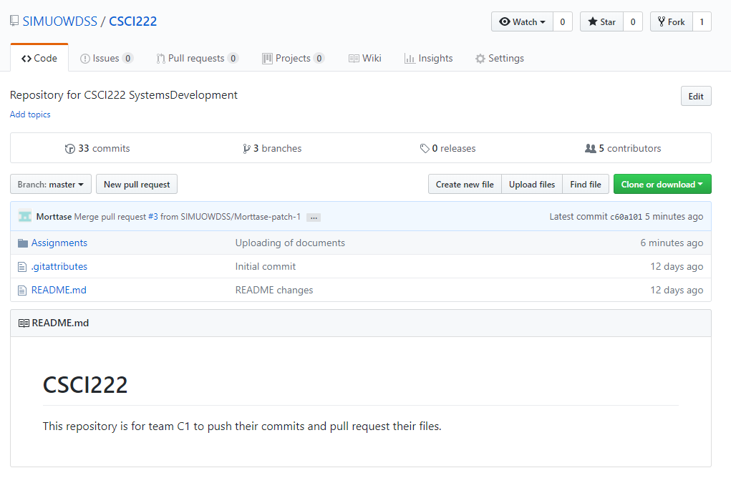
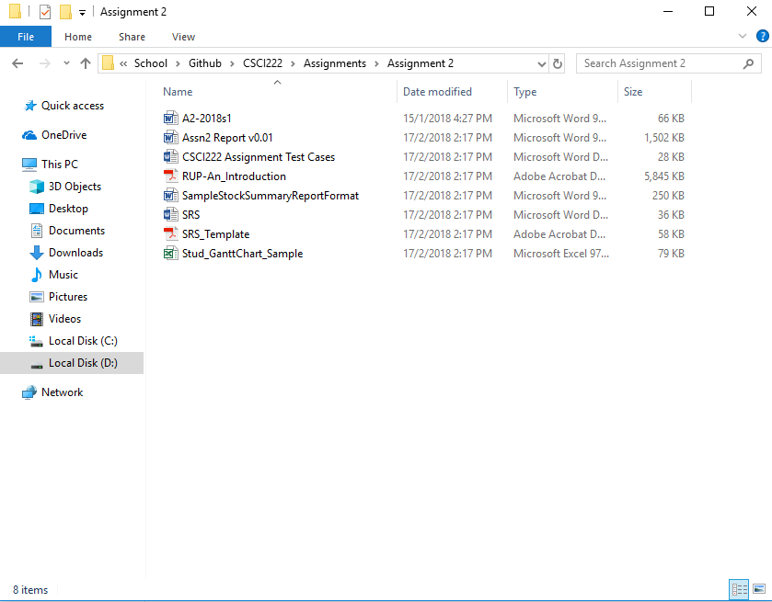
Figure C1.2 – The repository is cloned into your desktop based on the path you select. The folder then contains all the files and folders like in Github.

Screenshot #2 - VCS's listing of all the latest source files currently being managed

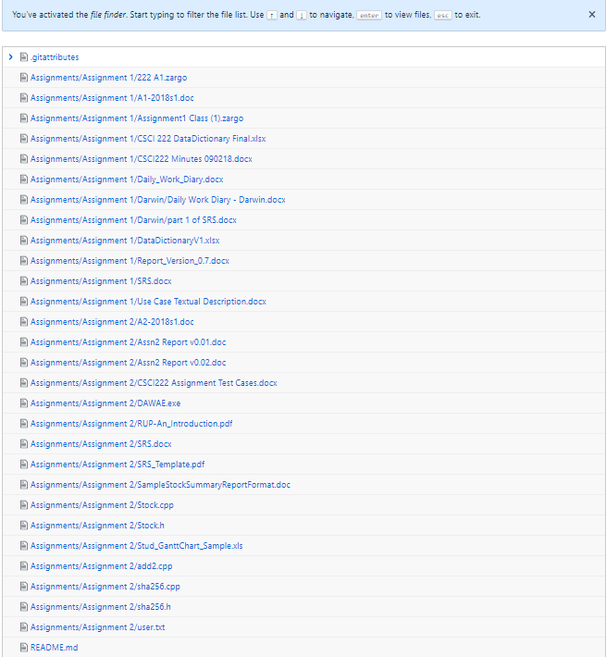
Figure C2.1 – This screenshot showcases the latest source files that are currently managed in our master repository.

Screenshot #3 - Example using VCS's to check-out source files (it may be necessary to do >1 screen capture, depending on the software used)

As per mentioned in our previous report, Github Desktop doesn’t require users to check out their files to avoid data collision. Github Desktop allows you to create and merge pull requests to avoid data collision.

Screenshot #4 - Example using VCS's to check-in source files (it may be necessary to do >1 screen capture, depending on the software used)

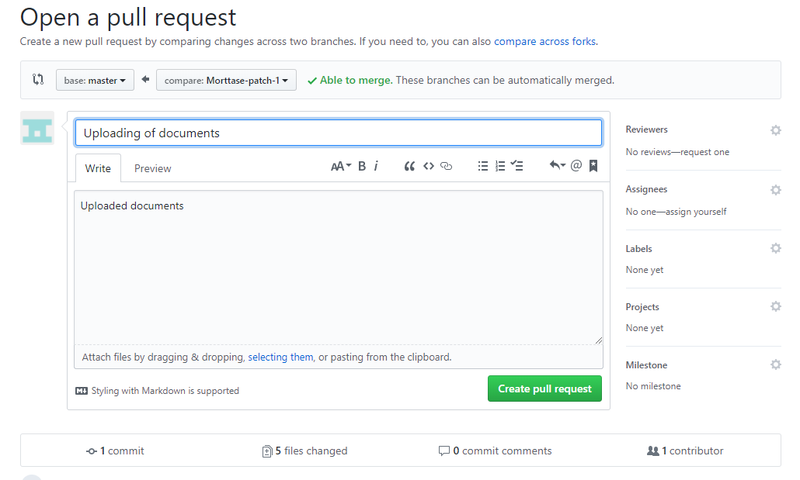
Figure C4.1 – This screenshot showcases the pull request that we are able to make upon uploading a file. Creating a pull request allows for the team to monitor the changed files before merging them into the master branch.
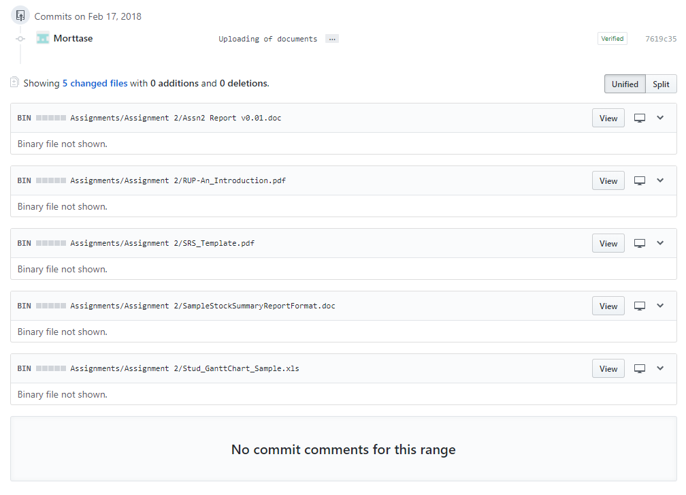
Figure C4.2 – This screenshot showcases all the changed files within a upload iteration by a particular user.
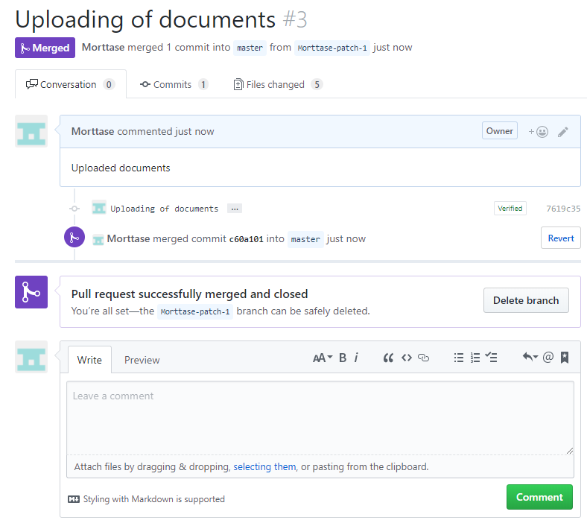
Figure C4.3 – This screenshot showcases the successful merging of documents. The repository will then be holding on to the latest version of the files that are edited and the pull request is then indexed.

Screenshot #5 - Example using VCS's to display the change history / log (it may be necessary to do >1 screen capture, depending on the software used)

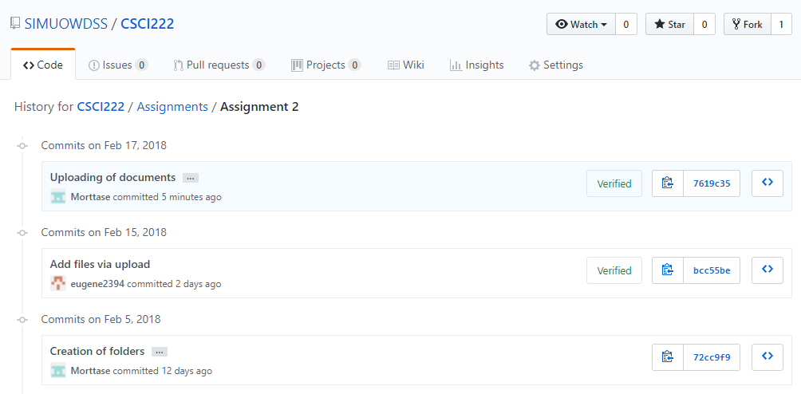
Figure C5.1 – This screenshot showcases the changes on the Github browser version.
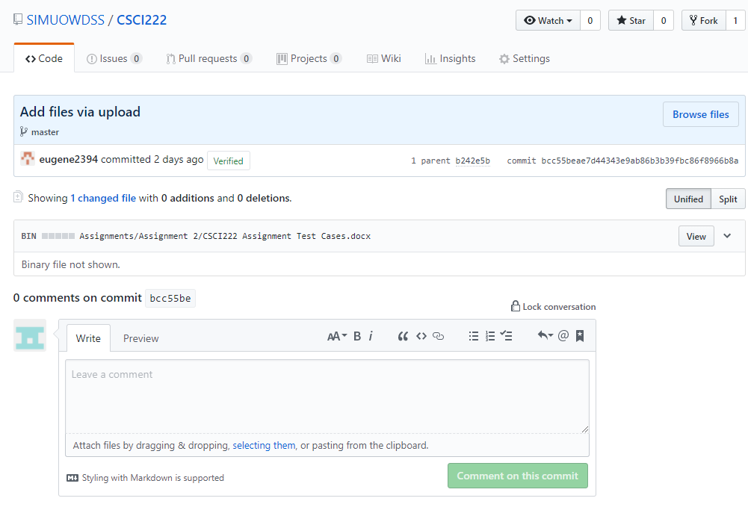
Figure C5.2 – This screenshot showcases a more detailed description of the changed file.
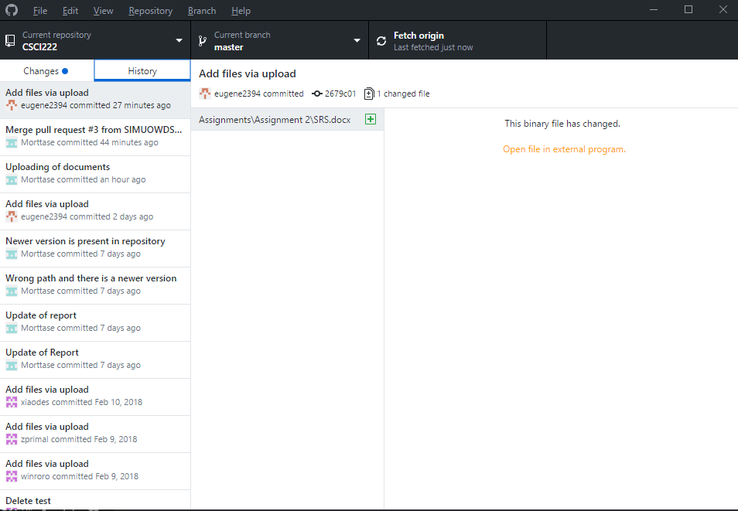
Figure C5.3 – This screenshot showcases the changes and history of changes made in Github Desktop GUI version.

